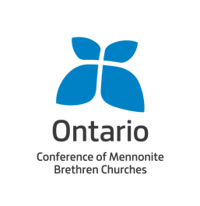
SPOUSAL REFERENCE FORM FOR CREDENTIALING APPLICANT

Thank you for participating in the credentialing process of your spouse. We recognize both the significant role that a spouse plays in the health and happiness of pastors and ministry leaders, and the particular challenges sometimes faced by spouses as they navigate congregational or constituency expectations. As such, your views on your spouse’s ministry work are essential to the credentialing process. We greatly value the unique and indispensable insights that a spouse brings into the process. These will also assist us in supporting our interest in the long-term well-being of the candidate, their spouse and family.

Name of Credentialing Candidate: Name of Spouse:

- Identify and describe some of your spouse’s character qualities, abilities, and spiritual gifts that you believe contribute to their suitability for their current or anticipated ministry role.

- Comment briefly on the nature of your spouse’s relationships with the various people in their life (for example, you, your children [if any], other family members, friends, neighbours, church members, students, etc.).

- How does your spouse respond to and handle conflict situations?

- How do you anticipate that your spouse’s current or anticipated ministry role will impact your marriage, family and other social relationships?

- To what extent do you agree with and support your spouse’s decision or intention to become involved in a pastoral or Christian leadership role in the Mennonite Brethren Conference?

- To what extent are you currently involved in your spouse’s ministry role, or anticipate being involved in the future?

- The work of ministry never happens in isolation, and a spouse will almost always experience the impact of the candidate’s ministry role in a way unlike anyone else. Have you experienced this in the past and, if so, how have you been able to manage this in a way that supports your spouse’s ministry? If you have not yet experienced this, how do you plan to handle any demands that may be placed on you by the congregation and/or constituency that your spouse will serve?

- Do you have any questions or concerns about the Mennonite Brethren Confession of Faith or about the Mennonite Brethren Conference that you do not understand, that you do not agree with or that you would otherwise like to have answered?

- Are there questions that you wish would have been included in the credentialing documents, but were not?

Completed forms should be sent by mail or email to the ONMB office.

Ontario Conference of Mennonite Brethren Churches
455 Geneva St. St. Catharines, ON L2N 2H2
Phone: 905-934-3398
Email: klee@onmb.org

