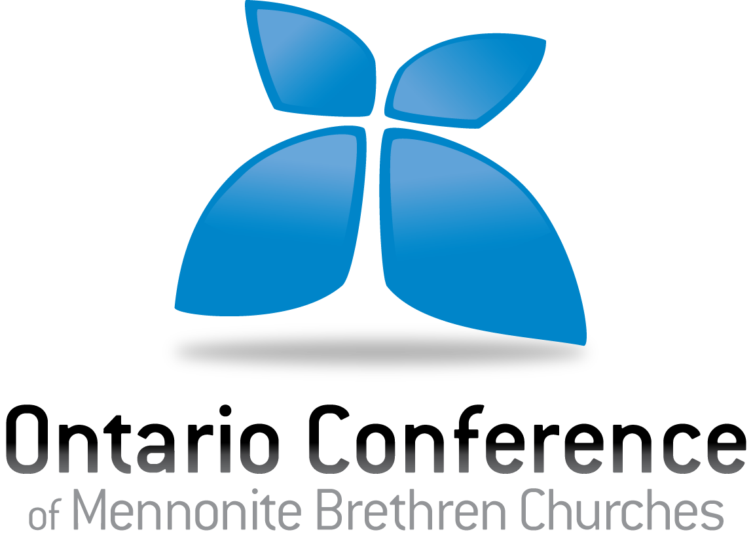

Ontario Conference of Mennonite
Brethren Churches

Mennonite Brethren Conference Covenant

- Do you affirm the Canadian Conference of Mennonite Brethren Churches Confession of Faith in all its aspects?

- Do you agree to live according to the Canadian Conference of Mennonite Brethren Churches Code of Christian Conduct included below?

- Are you willing to be in a relationship of mutual accountability with the Ontario Conference of MB Churches, and to serve in unity with fellow workers in the Conference?

- Will you actively seek to participate in, support and promote (as possible) the initiatives, mission, programs and ministries of both the provincial and national Mennonite Brethren conferences?

________________________________________ __________________________
Signature Date

Canadian Conference of Mennonite Brethren Churches
Code of Christian Conduct
Credential holders working with any of the provincial conferences or associated ministry agencies of the Canadian Conference of Mennonite Brethren Churches are spiritual leaders who are expected to live an exemplary Christian life in all aspects. Credential holders are to be guided by Biblical values concerning personal holiness, respect, responsibility, integrity, love and grace as outlined in the Confession of Faith, and as taught and understood in other documents and policies of the Canadian Conference of Mennonite Brethren Churches. These values emerge from a Mennonite Brethren understanding of what it means to love God with all our being and to love our neighbors as ourselves, and emphasize a Mennonite Brethren commitment to righteousness, moral and holy living, practicing justice, helping those in need, forgiving others, seeking forgiveness, and balancing personal freedom with a loving regard for others. Living according to these values involves a commitment on the part of all credential holders to embody attitudes and to practice actions identified in the Bible as virtues, and to avoid those portrayed as destructive or sinful.

The Canadian Conference of Mennonite Brethren Churches Code of Christian Conduct outlines the relationship between ministry, personal lifestyle and credentialing within the Ontario Conference of MB Churches. While credential holders may have a variety of personal views on certain lifestyle issues, it is expected that they will make exemplary ethical and Christian lifestyle choices that are consistent with the Code of Christian Conduct. Adherence to this Code of Christian Conduct is, therefore, an integral part of the credentialing process. All Ontario Conference of MB Churches credential holders are expected to renew this commitment every three (3) years as part of the Mennonite Brethren Covenant renewal process.

As a credential holder within the Ontario Conference of MB Churches, I commit myself to living in accordance with the following teachings and values by:

- having and maintaining a vibrant and healthy spiritual life that demonstrates a history of, and an ongoing commitment to, cultivating a personal relationship with God;
- maintaining healthy relationships that are conducive to the well-being of spouse and children (if applicable), and all others with whom one interacts;
- reserving sexual expressions of intimacy exclusively for the context of a covenantal marriage between a man and a woman;
- upholding the sanctity of marriage by not solemnizing, officiating, co-officiating, or otherwise affirming any marriage other than between one man and one woman;
- abstaining from communication that is destructive to inter-personal relationships, including gossip, slander, vulgar/obscene language, prejudice and abusive or demeaning language;
- abstaining from stealing, misusing or destroying property belonging to others;
- avoiding lying, cheating, financial impropriety, or other forms of dishonesty including plagiarism;
- avoiding drunkenness, addictive behaviors, the use or possession of illegal drugs, and the misuse or abuse of substances including prescribed drugs;
- avoiding the use of materials that are degrading, dehumanizing, exploitive, hateful, or gratuitously violent, including, but not limited to pornography;
- treating all persons with respect and dignity, and upholding their God-given worth from conception to death, including the avoidance of harassment, harmful discrimination and any form of verbal or physical intimidation; in these ways I will make every effort to demonstrate Christian love to all people;
- acting as responsible citizens both locally and globally who respect authorities, submit to the laws of this country when not inconsistent with Biblical teaching, and who contribute to the welfare of creation and society;
- demonstrating a love for Jesus by courageously sharing the gospel in word and deed;
- in all other ways, maintaining an active and healthy Christian life, consistent with the Christian teachings of Canadian Conference of Mennonite Brethren Churches, as an example to all with whom one meets and interacts.

When credential holders live or behave in contradiction to the Christian standards outlined in this statement, Ontario Conference of MB Churches first response will ordinarily be to seek a redemptive resolution to the situation. Ontario Conference of MB Churches leaders, along with local church leadership, are committed to working with credential holders who voluntarily, and if necessary with the assistance of counseling, restore Christian consistency in their lives. This does not mean that Ontario Conference of MB Churches and the local church will not also exercise their discretion to discipline Ontario Conference of MB Churches credential holders in the context of the employer-employee relationship (up to the point of termination of employment when appropriate).

________________________________________ _______________________
Signature Date
Please note: Individuals credentialed by the Ontario Conference of MB Churches will be asked to renew their commitment to the Mennonite Brethren Conference Covenant and the Mennonite Brethren Code of Christian Conduct every three years.

Completed forms should be sent by mail or email to the OCMBC office.
3970 Glendale Ave. | Vineland, ON | L0R 2C0 | info@onmb.org

