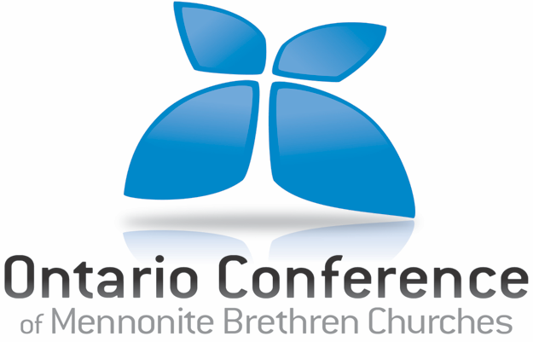

REFERENCE FORM FOR CREDENTIALING APPLICANT

Dear Brother/Sister in Christ:

Thank you for your willingness to participate in the credentialing process for the applicant. Please offer your candid perceptions of the candidate as outlined in the questions below.

Name of Credentialing Candidate: _______________________________

- Describe the nature of your relationship with the applicant (how long you have known him/her, in what context, etc).

- Identify and describe some of the applicant’s character qualities, abilities, and spiritual gifts that you believe contribute to their suitability for their current or anticipated ministry role.

- Describe your observations about the applicant’s relationship with God. From your perspective of the applicant’s spiritual health, what are her/his strengths, and what are some areas in which growth is needed?

- Describe your observations about the applicant’s marriage, family and other social relationships. From your perspective of the applicant’s relationships, what are his/her strengths, and what are some areas in which growth is needed?

- Describe your observations about the applicant’s leadership. What are her/his strengths, and what are some areas in which growth is needed?

- To what extent do you agree with and support the applicant’s decision or intention to become involved in a pastoral or Christian leadership role in the Mennonite Brethren Conference?

Form completed by:
Name:
Date:
Phone number:
Email:

Completed forms should be sent by mail, fax or email to the OCMBC office.

Ontario Conference of Mennonite Brethren Churches
Address: 3970 Glendale Ave., Vineland, ON L0R 2C0
Phone: 905-682-7978 ext. 122
Email: info@onmb.org

